OudhTrade
High-Level Design
V1 architecture — how OudhTrade is built to meet the PRD
Document details
Company | MRIDA INFRA AND PLANTATIONS LLP
Product | OudhTrade — oudhtrade.com
Scope | V1 architecture: R1 public web launch, R2 full web release, R3 mobile apps
Related documents | BRD & Business Plan · PRD · master database design · module documents
Owner | Tech lead [TBC: name]; approved with the product owner
Decision owner | T. Satish Reddy, CEO & Founder
Status | Draft for review — 23 September 2026
Classification | Confidential — for partners and the OudhTrade team

Contents
1. About This Document 4
1.1 How decisions are labelled 4
2. Architecture Principles 5
3. System Context 6
4. Application Architecture 7
4.1 Deployable units 7
4.2 Modules 7
4.3 How modules work together 9
5. Deployment Architecture 10
5.1 Environment and network 10
5.2 Availability and recovery 10
5.3 Indicative year-1 sizing 11
5.4 Domains, DNS and certificates 12
5.5 High availability of supporting services 12
5.6 CDN cache rules 12
6. Data Architecture 13
6.1 Data stores 13
6.2 Keeping stores in step (outbox) 13
6.3 Data classification 14
6.4 Retention and deletion 14
6.5 Analytics store 14
7. Key Flows 15
7.1 Listing publishing and moderation 15
7.2 Business and farmer verification 16
7.3 Search (keyword + meaning, with fallback) 17
7.4 Register interest (R1) and chat (R2) 18
7.5 Requirement matching 19
7.6 Trade confirmation, review and trust 19
7.7 Subscription payment and GST invoice 20
7.8 Court or government order (3-hour removal) 20
8. Integrations 21
8.1 Email deliverability 23
9. AI Architecture 24
10. Security & Privacy 25
10.1 Identity and access 25
10.2 Protection controls 25
10.3 Privacy (DPDP) and logging 26
11. Configuration Architecture 27
12. Cross-Cutting Design 28
12.1 Observability tools 28
13. Technology Decisions 29
13.1 Fixed 29
13.2 Team proposes (with rules) 29
13.3 Supplier shortlist 29
14. Risks & Open Items 31
14.1 Architecture risks 31
14.2 Open items 31
Appendix A — Glossary 32
Appendix B — Event catalogue 33

1. About This Document
This High-Level Design (HLD) describes how OudhTrade V1 is built to meet the PRD. It records the architecture decisions, the main components and how they work together. It is written for the tech lead, developers, DevOps, QA and the security auditor.
Document | Role
PRD | What the product must do and the rules (requirement IDs PRD-xxx-nnn)
HLD (this document) | Architecture: components, deployment, data, flows, security, technology decisions
Master database design | Tables, keys, indexes and data dictionary (built from Section 6)
Module documents | Backend, frontend and database design per module, following this HLD

1.1 How decisions are labelled
Label | Meaning
Fixed | Decided; changing it needs a change request approved by the tech lead and product owner.
Team proposes | The development team proposes the choice against the rules in this HLD; the tech lead approves.
Shortlist | A supplier shortlist; the final supplier is chosen during the related module’s tuning.
[TBC: …] | Open item listed in Section 14.

The HLD covers V1 as one design (R1 public web launch, R2 full web release, R3 mobile apps). Release sequencing is handled by the team; the architecture must not need rework between releases.

2. Architecture Principles
# | Principle | What it means for the build
1 | API-first | Every function used by the web is a versioned API; web, apps, admin and future AI agents use the same API and rules.
2 | Modular monolith | One codebase and one database, split into 20 modules with strict boundaries. Simple to run for a small team; modules can be split out later if ever needed.
3 | One global site, data in India | One marketplace for all countries; all personal data stored and processed in AWS Mumbai with a warm standby and backups in Hyderabad.
4 | PostgreSQL is the source of truth | Search indexes, caches and analytics are copies that can be rebuilt from PostgreSQL.
5 | Configurable, not hard-coded | Categories, permissions, limits, weights, prices and texts are data managed in the Configuration Console, with versions and approvals.
6 | Reliable events | Changes that other parts must react to are written as events in the same database transaction (outbox) and delivered at least once; handlers are idempotent.
7 | Secure and private by default | Least privilege, encryption everywhere, private files, audit log, DPDP and CERT-In built in from R1.
8 | AI through one gateway, humans in control | All AI calls pass through an AI gateway with logging and cost limits; AI never takes enforcement or verification decisions.
9 | Managed services first | Use AWS managed services where they meet residency and control needs; run our own only where needed (Typesense, Keycloak).
10 | Everything as code | Infrastructure, configuration defaults, database migrations and pipelines are versioned in the repository.
11 | Observable | Logs, metrics, traces and alerts for every service, tied to the PRD service levels.
12 | Web first, apps without rework | The API is designed for mobile from the start so R3 apps need no new backend.

3. System Context
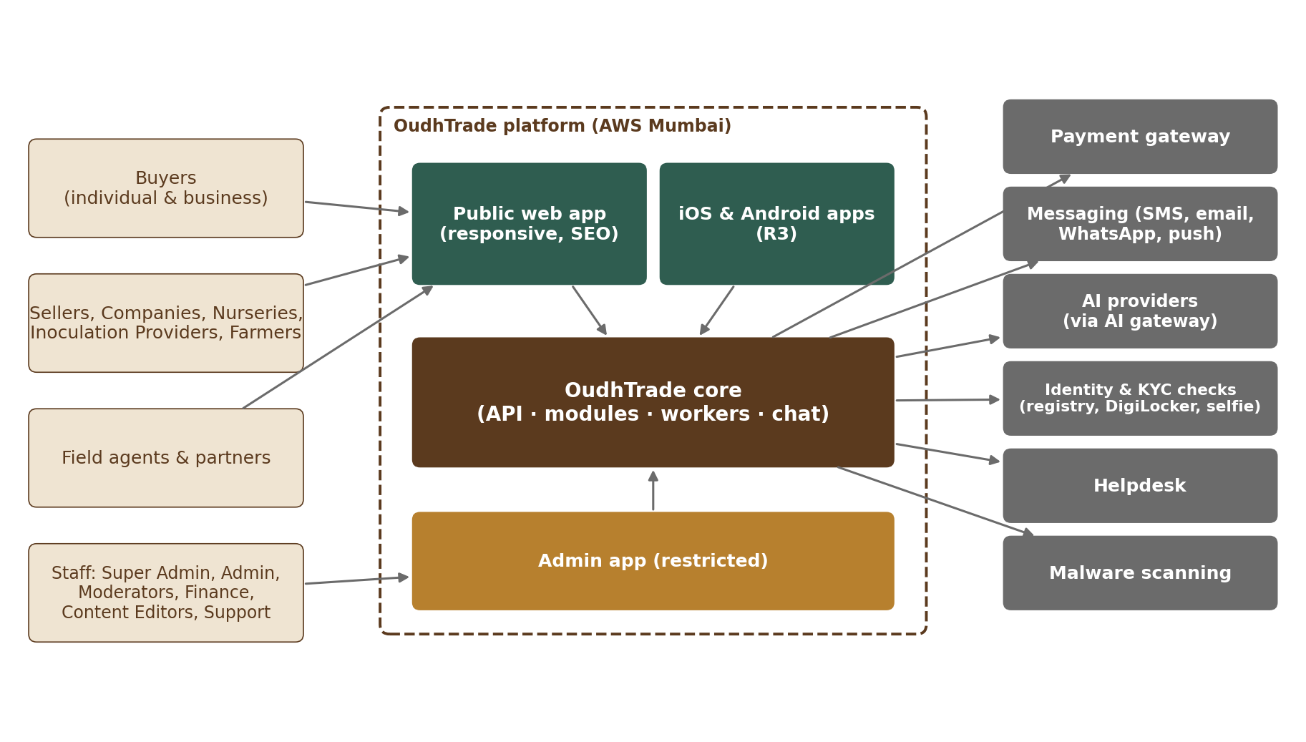
Figure 1 — System context — users, OudhTrade and external systems
Actor / system | Interaction
Buyers, sellers, companies, nurseries, inoculation providers, farmers | Use the public web app (R1–R2) and native apps (R3) through the public API
Field agents and partners | Use the web app with delegated permissions to onboard farmers with consent
Staff (Super Admin, Admin, Moderator, Finance, Content Editor, Support) | Use the separate Admin app, reachable only through VPN / IP allow-list with SSO and 2FA
Payment gateway | Hosted checkout for plans, ads and paid services; signed webhooks back to OudhTrade
Messaging providers | Email, SMS (DLT templates), WhatsApp (opt-in messages and sign-in codes by authentication template) and push notifications
Google and Apple sign-in | Optional sign-in with a Google or Apple account, brokered by Keycloak (Section 10.1)
AI providers | Embeddings, moderation assist, listing assistant — only through the AI gateway
Identity and verification services | Registry checks and auto-fill (GSTIN, PAN, MCA, Udyam; IEC check with DGFT where possible), DigiLocker, Aadhaar OTP e-KYC through a UIDAI-licensed provider (after UIDAI approval), selfie and liveness check, bank account check, document forgery check, link safety scan and link ownership check, sanctions lists — during Module 3 verification (Section 8)
Helpdesk | Tickets, email and WhatsApp support; linked to user accounts
Malware scanning | Every uploaded file is scanned before storage or display

4. Application Architecture

4.1 Deployable units
Unit | Purpose | Notes
Web app | Public website and user dashboards (responsive, desktop-first) | Server-side rendering for public pages (SEO, speed on 4G)
Core API | All business logic of the 20 modules; REST API; real-time chat connections | Stateless containers, scaled horizontally
Workers | Background jobs: outbox relay, indexing, matching, notifications, photo processing and safety checks, video conversion, exchange-rate fetch, scheduled tasks | Same codebase as the Core API, different start command
Admin app | Operations Console and Configuration Console for staff | Separate deployment on a private load balancer; separate identity realm
Keycloak | Identity: sign-up, sign-in (password, Google, Apple), OTP, sessions, staff 2FA | Self-hosted in Mumbai, on its own small RDS PostgreSQL database (Fixed)
Typesense | Search index: keyword + vector (meaning) search | Self-hosted 3-node cluster in Mumbai (Fixed)
Field-agent offline web app (R1) | Installable web app (progressive web app) for field agents: farmer profile, the in-person confirmation (ID seen and declaration) and farm-visit reports are filled offline, kept encrypted on the device and sent when signal returns; the farmer’s code confirmation happens once online (M03) | Part of the web app code; uses the same versioned API; no separate backend
Mobile apps (R3) | iOS and Android | Use the same versioned public API

4.2 Modules
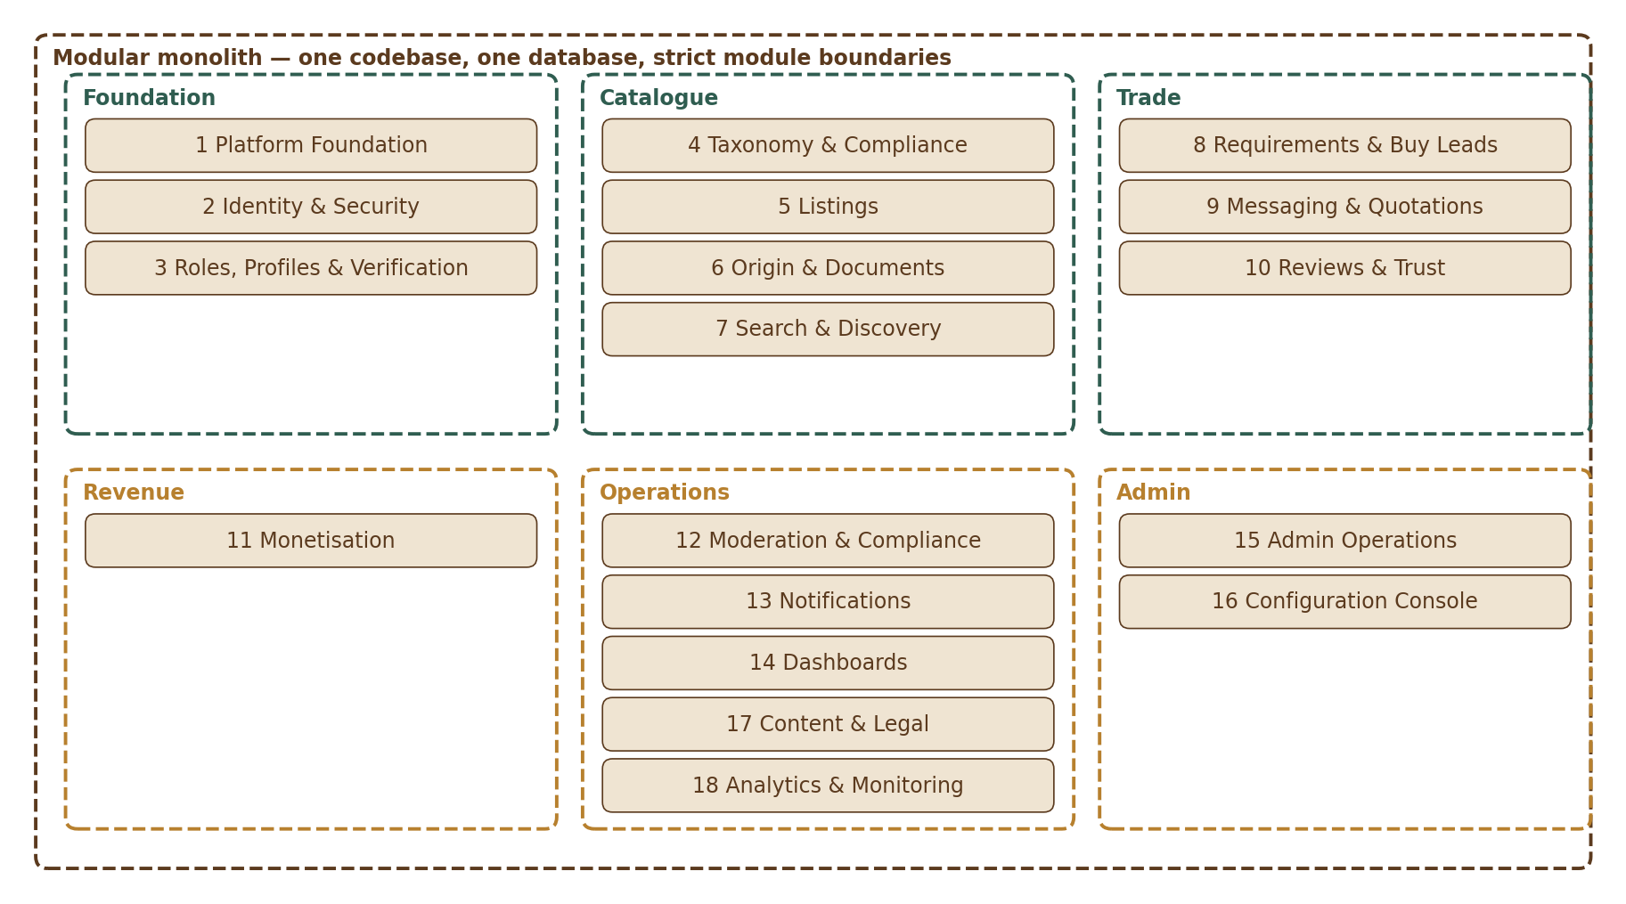
Figure 2 — The 20 modules inside the modular monolith
Each module owns its tables and exposes a small internal interface. Modules never read or write another module’s tables directly; they call its interface or react to its events. This keeps the monolith easy to change and makes it possible to split a module out later. The event names below are fixed in Appendix B — Event catalogue.
Module | Main responsibility | Events it publishes (Appendix B)
1 Platform Foundation | Files and video, photo safety, units, translations, Country table and guide rates, rate limits, audit log, settings and feature flags | file.ready, file.held, file.rejected, config.published, fx.rates_updated, security.rate_block, legal_hold.placed / legal_hold.released
2 Identity & Security | Accounts, sign-in, sessions, account states, recovery, delegation, consent, account country and sanctions checks | account.created, account.state_changed, account.closed, delegation.granted / delegation.revoked, account.risk_flagged, consent.changed
3 Roles, Profiles & Verification | Roles, role dashboards and setup card, profiles, business details, identity check, verification and enhanced check, farm visits, FPOs, field agents, partners, badges | profile.verified, profile.renamed, verification.decided, role.changed, badge.changed, profile.reverification_started, supply.flagged
4 Taxonomy & Compliance Rules | Categories, items, attributes, permissions, compliance settings | —
5 Listings | Listing lifecycle, Opportunities rules, bulk upload | listing.published, listing.updated, listing.removed
6 Origin & Trade Documents | Document library, origin declarations, document requests, origin chain | document.deleted
7 Search & Discovery | Search API, ranking, storefronts, buyer tools | —
8 Requirements & Buy Leads | Requirement posts, matching, buy-lead inbox | requirement.posted
9 Messaging & Quotations | Register interest, chat, quotations, safety filters | enquiry.created, message.deleted
10 Reviews & Trust | Trade confirmation, reviews, trust score | trade.confirmed
11 Monetisation | Plans, entitlements, Ad Engine, billing, invoices | plan.changed
12 Moderation & Compliance Ops | Automatic checks, queues, reports, enforcement, legal orders | moderation.file_decided, content.taken_down, moderation.account_action
13 Notifications | Templates, channels, preferences, delivery | —
14 Dashboards | Read models for seller, buyer and farmer dashboards | —
15 Admin: Operations Console | Queues, user search, KPI views | —
16 Admin: Configuration Console | Versioned configuration with approvals and rollback | — (after approval, Module 1 publishes config.published)
17 Content & Legal | CMS, legal pages with versions, guides, market intelligence | —
18 Analytics & Monitoring | Product events, funnels, KPI data | —
19 Mobile Apps | Native clients (no separate backend) | —
20 Testing & Go-Live | Test automation, load tests, launch checks | —

4.3 How modules work together
- Direct calls through a module’s interface when an answer is needed immediately (e.g. Listings asks Taxonomy whether a role may list an item).
- Events through the outbox when other modules only need to react (e.g. listing.published → Search indexes it, Notifications informs followers).
- Entitlements (plan limits) are checked through one Monetisation interface so every module applies plan rules the same way.
- Permissions are checked centrally: role + account state + ownership + configurable permission table, on every request.

5. Deployment Architecture
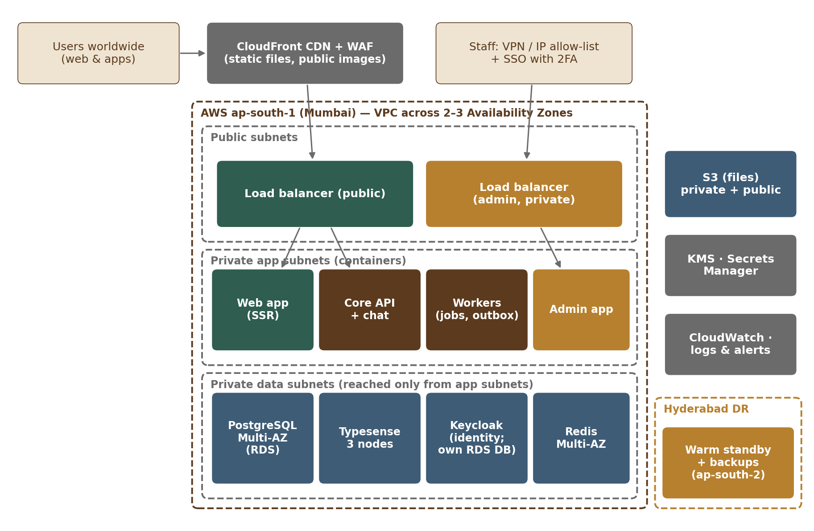
Figure 3 — Deployment on AWS — Mumbai primary, Hyderabad warm standby

5.1 Environment and network
- Region: AWS ap-south-1 (Mumbai), spread across 2–3 Availability Zones. Disaster recovery: a warm standby and backup copies in ap-south-2 (Hyderabad), keeping all data in India (Section 5.2).
- Network zones: public subnets hold only load balancers; application containers run in private subnets; databases, search, identity and cache run in isolated data subnets with no internet access.
- Edge: CloudFront CDN with AWS WAF (managed rules, Bot Control, IP reputation), anti-scraping and rate-based rules, geo-blocking of countries marked “blocked” in the Country table, and AWS Shield Standard. Personal data and private pages are never cached at the CDN (Section 5.6).
- Admin: separate private load balancer, reachable only through VPN or IP allow-list, with SSO and mandatory 2FA.
- Containers: a managed container service (ECS Fargate suggested; team proposes). Services scale on CPU and request count.
- Environments: development, staging (production-like, made-up data and the demo data set only) and production, each in its own AWS account. Production data is never copied to staging or development, not even in anonymised form.

5.2 Availability and recovery
Item | Design | Target
Main database (Mumbai) | PostgreSQL (RDS) Multi-AZ with automatic failover; continuous backup with point-in-time restore | RPO 5 minutes within Mumbai
Warm standby (Hyderabad) | Cross-region read replica of the main database in ap-south-2, a few seconds behind; takes no user traffic. If the Mumbai region fails, it is promoted to primary and the site is pointed there. | Region loss: data loss of seconds (target ≤ 1 minute)
Keycloak database | Own small RDS PostgreSQL instance with a cross-region replica in Hyderabad | Same as the main database (region loss ≤ 1 minute)
Backups | Automated daily snapshots + continuous logs; snapshot copies to Hyderabad; S3 cross-region replication for files | Kept for the backup period (M01-FR-ENV-009)
Search | Typesense 3-node cluster across zones; nightly snapshot to S3; rebuilt from PostgreSQL after a region loss; database search fallback | Search keeps working
Cache | Redis Multi-AZ with automatic failover; after a region loss it is rebuilt empty | Nothing that cannot be lost
Application | At least 2 containers per service across zones behind load balancers; after a region loss, containers are created in Hyderabad from the infrastructure code | 99.0% monthly availability in R1, 99.5% from R2
Recovery time | Whole service running again after a major failure, including a region loss | RTO 24 hours in R1, 8 hours from R2
Drills | Restore drill before R1, then every quarter (a production backup restored into an isolated account, RPO and RTO timed); region failover drill every year (the standby promoted in a test) | Proven recovery
DR plan | Written disaster recovery plan with the steps above; owner: tech lead [TBC: name] | Reviewed after each drill

Year 2 option: the Hyderabad copy may also serve search or reports, a first step toward running in both regions at once (active-active).

5.3 Indicative year-1 sizing
Sized for about 100,000 listings, 50,000 users and 25 searches per second at peak with 3× headroom (PRD). Starting point, to be confirmed by load tests:
Component | Starting size
Core API | 2–4 containers (2 vCPU, 4 GB each), auto-scaling
Workers | 2 containers, auto-scaling on queue depth
Web app (SSR) | 2–3 containers
PostgreSQL | Multi-AZ, 4 vCPU / 16 GB class, 200 GB storage with auto-growth
PostgreSQL warm standby | One cross-region read replica in Hyderabad, same class as the primary so it can take over
PostgreSQL read replica | From R2: one read replica in Mumbai for reports and dashboards. In R1 the read-only reporting user (app_readonly) reads the primary with query time limits.
Keycloak | 2 containers across zones; own small RDS PostgreSQL instance
Typesense | 3 nodes, 4 GB RAM each
Redis | Small managed cluster, Multi-AZ (cache, rate limits, chat presence, frequency limits, WebSocket fan-out (pub/sub))
Malware scanning | ClamAV scanner workers, auto-scaling on queue depth
S3 | Private bucket (originals, documents), public bucket (processed photos and 720p videos via CDN)

5.4 Domains, DNS and certificates
Item | Design
DNS | AWS Route 53 hosts the oudhtrade.com zone; DNSSEC switched on
Domain registration | Registrar lock on; auto-renew on
Certificates | AWS Certificate Manager (ACM) certificates, renewed automatically
Sub-domains | www — public website · api — public API · admin — Admin app (private, VPN / IP allow-list) · accounts — sign-in host for the Keycloak sign-in pages (accounts.oudhtrade.com [TBC]) · cdn / media — photos, videos and static files · status — public status page (hosted outside the main AWS account)

5.5 High availability of supporting services
Service | Design
Keycloak | 2 containers across zones; own RDS PostgreSQL database (Section 6.1)
Typesense | 3 nodes across zones; nightly snapshot to S3; can always be rebuilt from PostgreSQL
Redis | Multi-AZ with automatic failover
Real-time chat | WebSocket messages fanned out between Core API containers through Redis pub/sub, so any container can deliver to any user
Malware scanning | ClamAV scanners run as auto-scaling workers; files stay in quarantine until scanned

5.6 CDN cache rules
- Public pages are cached at the CDN only without personal data; private pages, dashboards and API answers with personal data are never cached.
- The guide price is filled in on the viewer’s device (or the cache is kept separate per guide currency), so a page is never cached with the wrong currency.
- The cache for a page is purged when listing.removed or content.taken_down is published (Appendix B).

6. Data Architecture
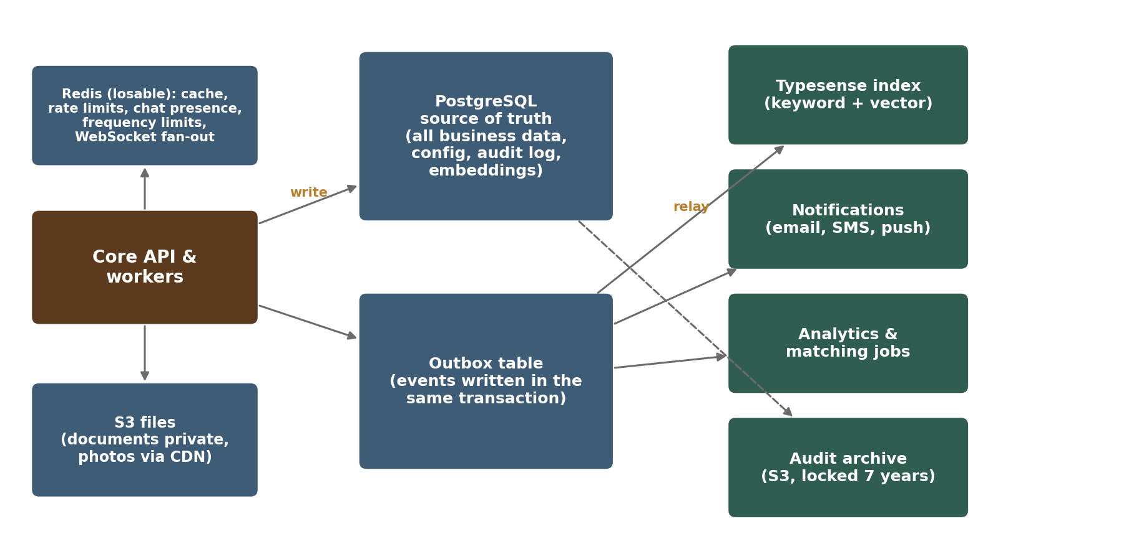
Figure 4 — Data stores and how data flows between them

6.1 Data stores
Store | Holds | Rule
PostgreSQL | All business data (one schema per module), configuration versions, audit log, search embeddings (Search module schema), outbox, job queue | Source of truth; every other store can be rebuilt from it
PostgreSQL read replica (from R2) | Copy of the main database in Mumbai, read through documented reporting views | Reports and dashboards only; in R1 the read-only reporting user reads the primary with query time limits
Typesense | Search documents for listings, storefronts, requirements (for matching) | Derived copy; updated from the outbox within 60 seconds
S3 | Documents (private, signed short-lived links), photos (processed, public via CDN), exports, audit archive | Encrypted; audit archive with object lock for 7 years
Redis | Cache, rate limits, chat presence, frequency limits, WebSocket fan-out (pub/sub) | Nothing that cannot be lost
Keycloak database | Credentials, sessions, identity data | Own small RDS PostgreSQL instance with its own backups and database user; not in the main database; only Keycloak accesses it

6.2 Keeping stores in step (outbox)
When a module changes data that others must react to, it writes the change and an event row in the same database transaction. A relay worker reads new events and delivers them to handlers (search indexing, notifications, matching, analytics). Delivery is at least once, so every handler is idempotent. If Typesense is lost, the index is rebuilt from PostgreSQL.

6.3 Data classification
Every type of data uses one of the four sensitivity levels of the NFR (Section 6.5), which also sets the handling rules. Examples:
Level | Examples
Public | Published listings, public profile details, processed photos and videos, guide prices, guides and help pages
Internal | Source code, configuration, runbooks, non-personal metrics, business reports
Confidential | Personal data (names, phone, email, IP address), messages, enquiries, requirement posts, verification status, invoices, seller business documents, moderation notes
Restricted | ID documents and government ID and document numbers, verification documents, selfies and identity-check results, photo location, passwords, keys and secrets, audit log, breach records

6.4 Retention and deletion
A retention schedule per data type (PRD-CMP) is implemented as scheduled jobs that delete or anonymise data when its purpose ends, except records the law requires us to keep (e.g. invoices, audit log 7 years, security logs ≥ 180 days, processing logs ≥ 1 year). Legal holds stop deletion for data linked to an open legal order or dispute. Module 3 examples: a selfie is deleted right after the identity check (the result is kept); rejected or replaced verification documents are deleted 90 days after the decision.

6.5 Analytics store
- Page views, searches and clicks go to a separate analytics store, not to PostgreSQL [TBC: choice in M18].
- The store must be hosted in India, or receive only pseudonymous events (a random ID in place of the account; no names or contact details).
- Key counts (page views, listing views, enquiries, sign-ups) are also counted on the server without cookies (Module 1).

7. Key Flows
Sequence diagrams for the flows that cross several modules. Module documents add the detailed steps, errors and screens.

7.1 Listing publishing and moderation
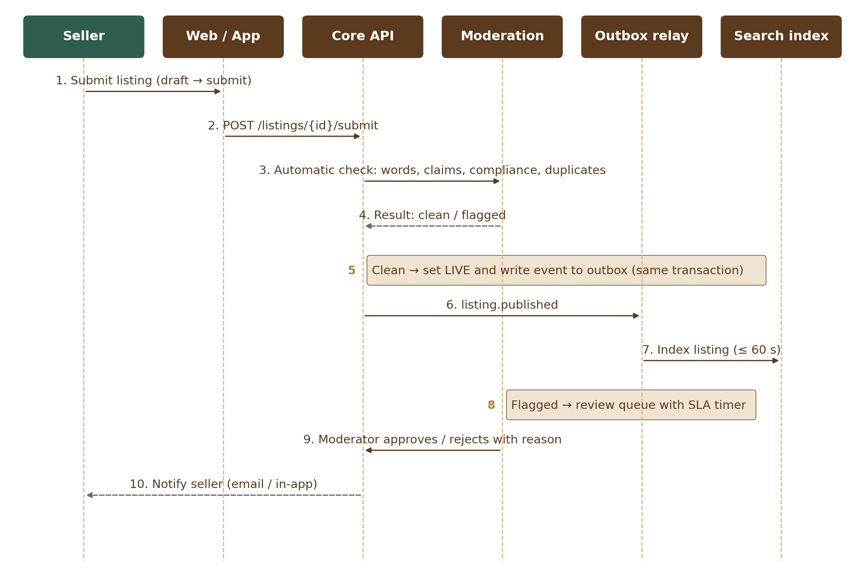
Figure 5 — 7.1 Listing publishing and moderation

7.2 Business and farmer verification
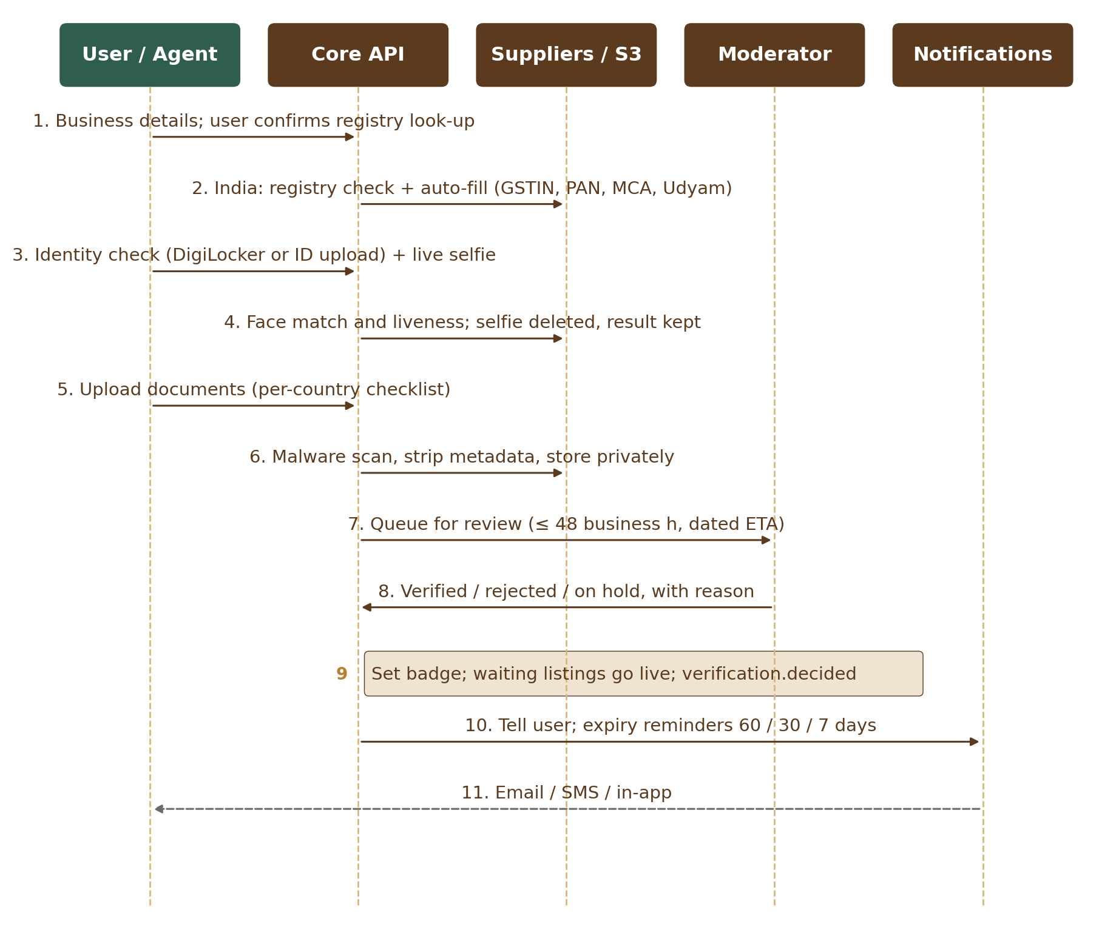
Figure 6 — 7.2 Business and farmer verification

7.3 Search (keyword + meaning, with fallback)
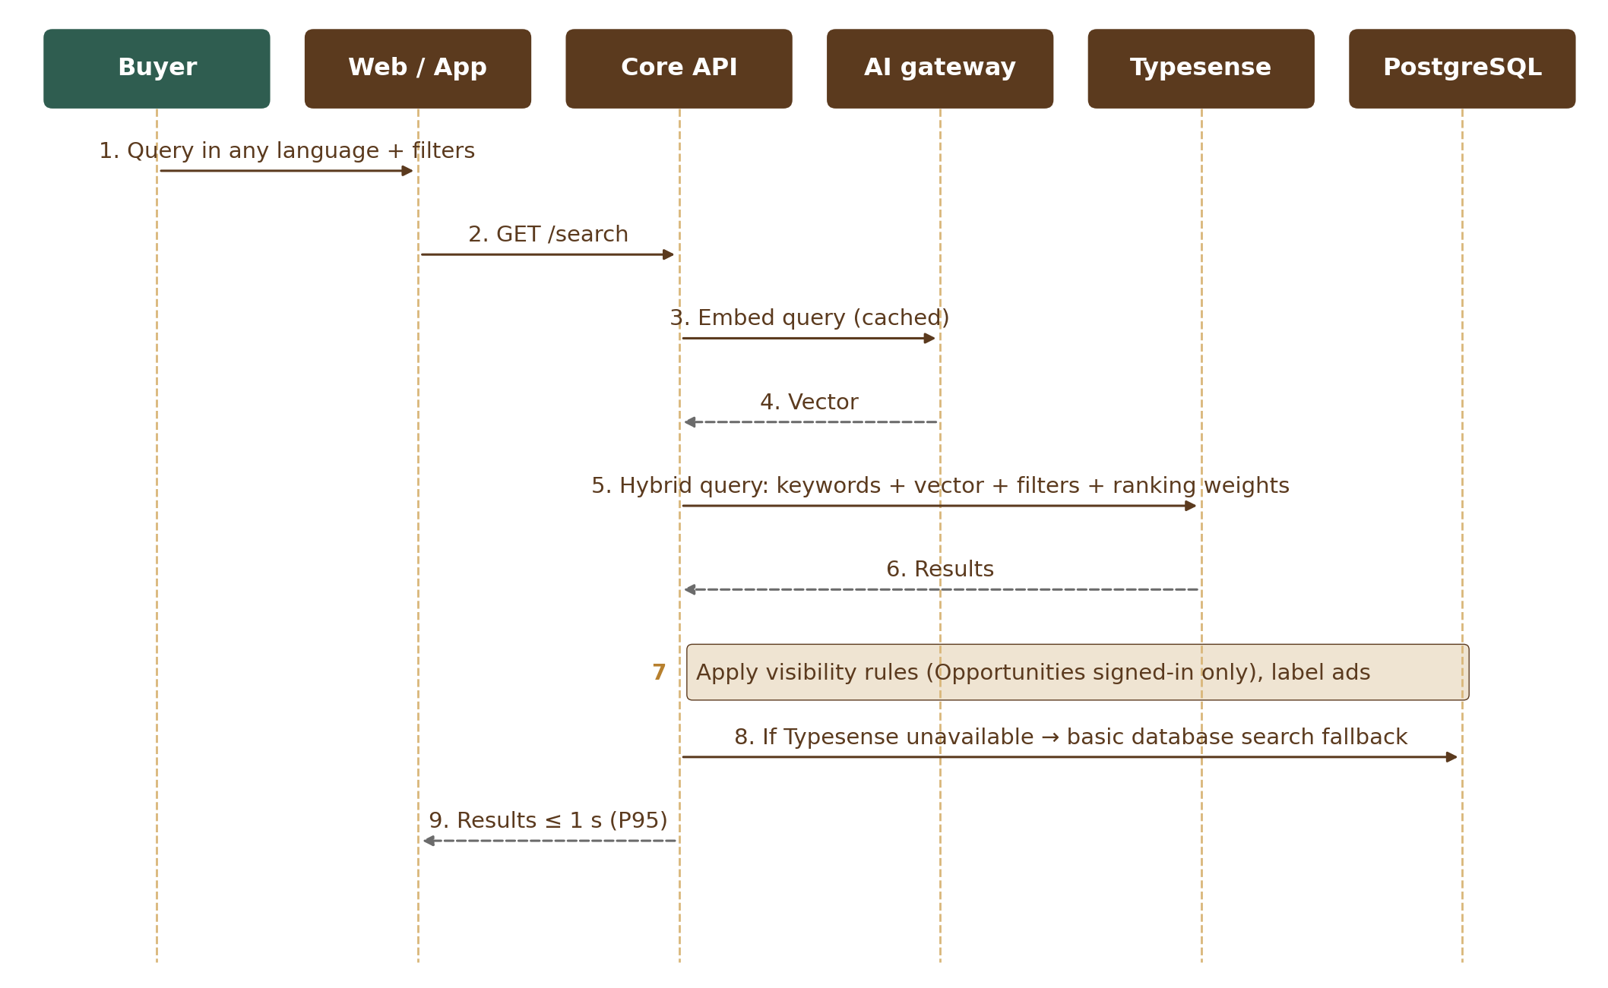
Figure 7 — 7.3 Search (keyword + meaning, with fallback)

7.4 Register interest (R1) and chat (R2)
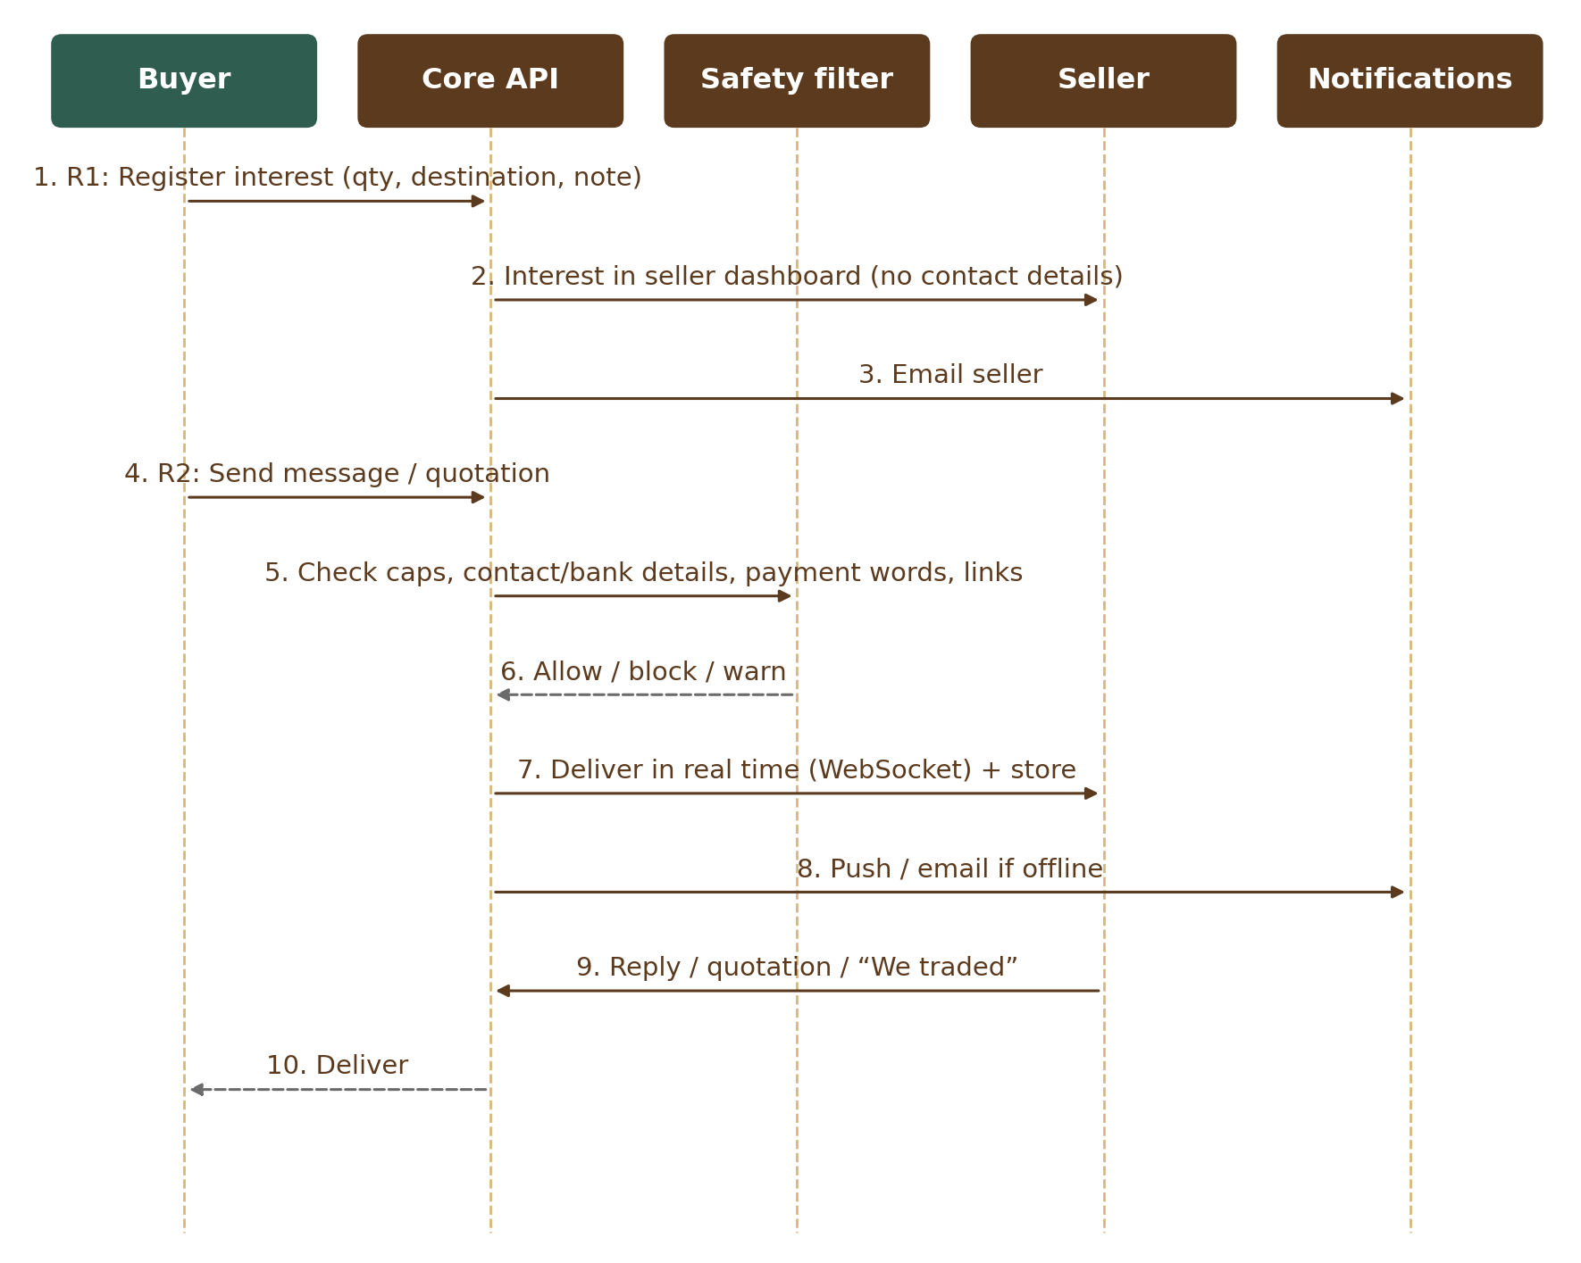
Figure 8 — 7.4 Register interest (R1) and chat (R2)
Chat uses WebSocket connections to the Core API; messages are always stored in PostgreSQL first, then pushed. The safety filter runs on the server for every message: trust-based caps, blocking contact / bank / UPI details and links for new or unverified accounts, and warnings on payment words. Automatic messages are labelled and do not count toward caps.

7.5 Requirement matching
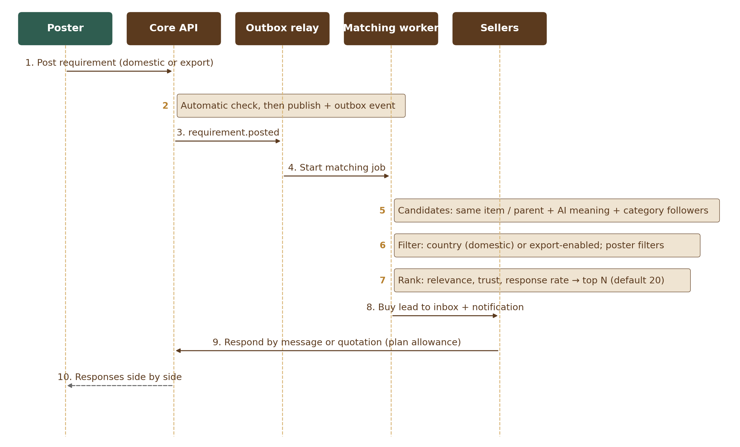
Figure 9 — 7.5 Requirement matching

7.6 Trade confirmation, review and trust
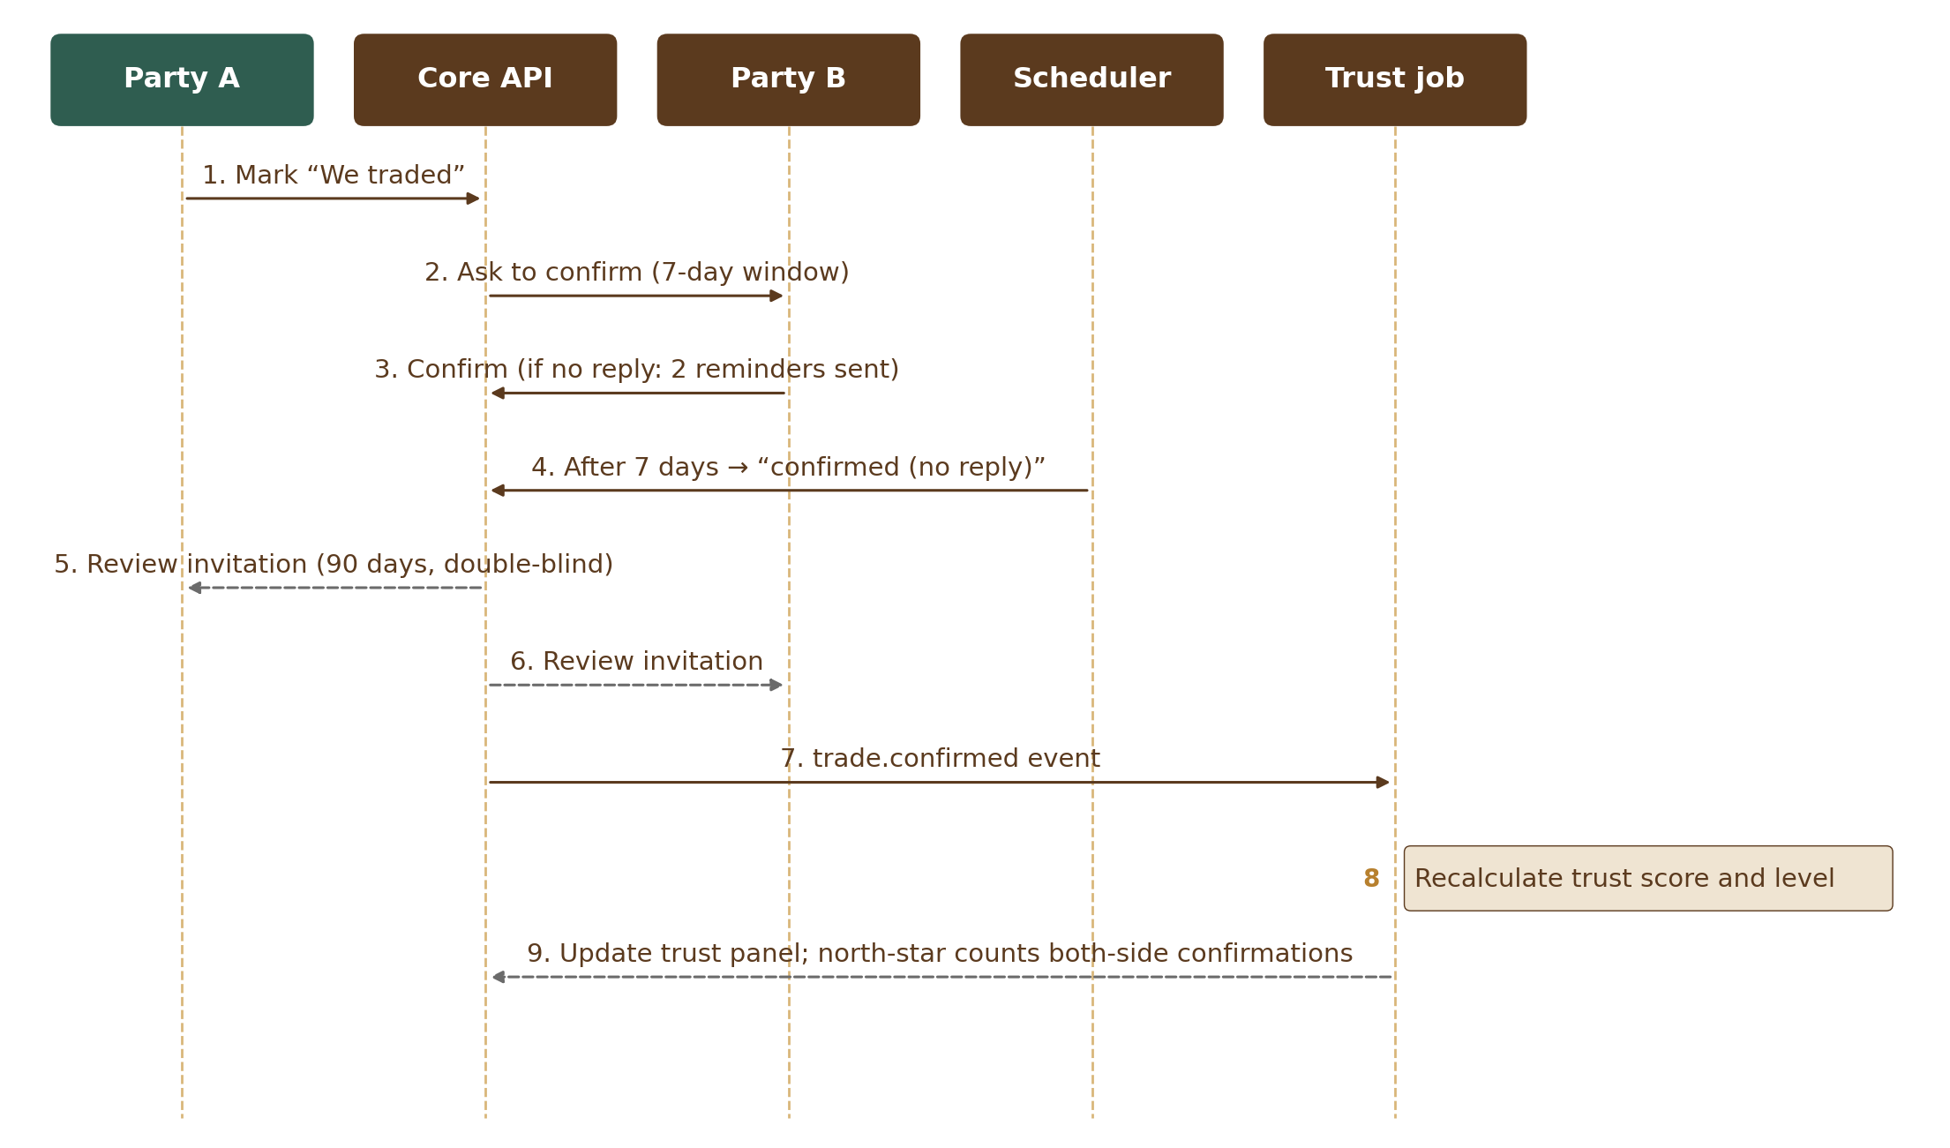
Figure 10 — 7.6 Trade confirmation, review and trust
Trust scores are recalculated on events (new review, upheld report, verification change) and by a nightly job for time-based parts (activity, review ageing). Weights come from the Configuration Console.

7.7 Subscription payment and GST invoice
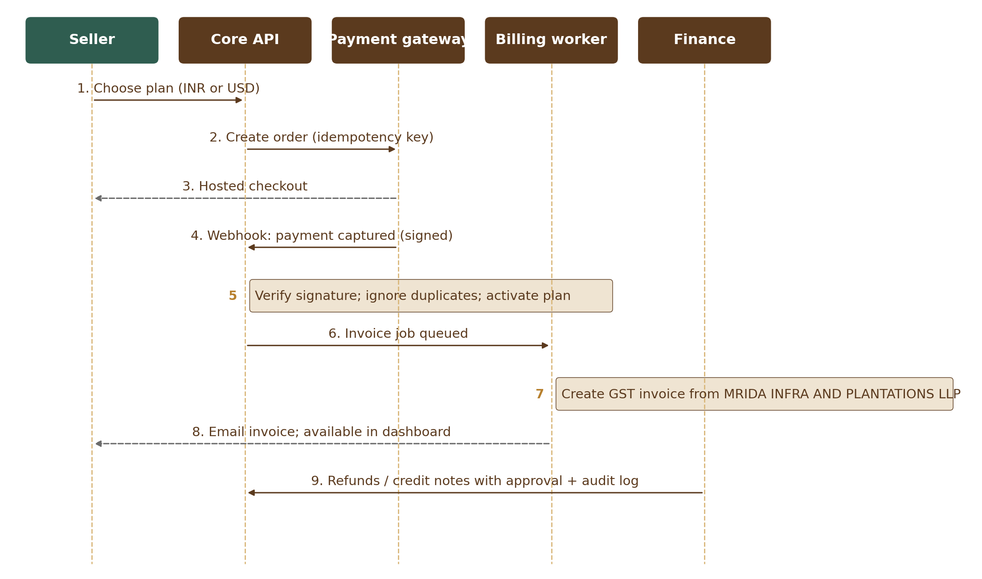
Figure 11 — 7.7 Subscription payment and GST invoice

7.8 Court or government order (3-hour removal)
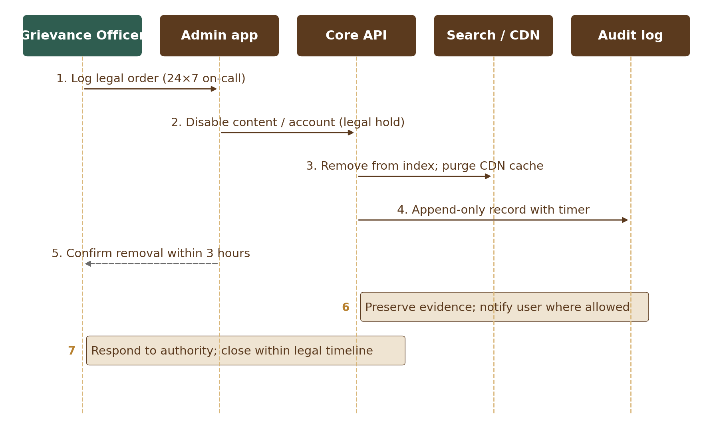
Figure 12 — 7.8 Court or government order (3-hour removal)

8. Integrations
Service | Purpose | Shortlist | Data shared | If it fails
Payment gateway | Plans, ads, paid services (INR and USD) | Razorpay or Cashfree | Order, amount, name, email | Checkout unavailable; retry; plan not changed until webhook
SMS | OTP and alerts (DLT templates in India); OudhTrade sender names registered in Saudi Arabia and UAE before R2 | MSG91 or Gupshup | Phone number, template text | Fallback provider or email OTP
Email | Transactional and newsletter | AWS SES (Mumbai) | Email, message | Queued and retried
WhatsApp | Opt-in notifications, support; sign-in codes outside India (authentication templates) | Meta Cloud API via provider | Phone, template | Codes: SMS, then email; other messages: email / in-app
Google Sign-In | Optional user sign-in (R1); hidden where Google is blocked | Google (OpenID Connect) | Name, email, Google provider ID | Sign in with password
Sign in with Apple | Optional user sign-in (R1) | Apple (OpenID Connect) | Name, email (may be a private relay address), Apple provider ID | Sign in with password
Push (R3) | App notifications | Firebase Cloud Messaging, Apple Push | Device token, message | In-app inbox still shows it
Malware scan | Scan every upload | ClamAV (self-hosted) | File (stays in AWS) | File held in quarantine until scanned
Video conversion | Listing videos to 720p + cover image | AWS Elemental MediaConvert or FFmpeg worker (team proposes) | Video (stays in AWS) | Video stays in “processing”; retried
Photo text / QR check | Find contact details and QR codes in photos | Self-hosted OCR and QR libraries or a managed service in Mumbai (team proposes) | Photo (stays in India) | Photo held for manual review
Exchange rates | Daily rates for guide prices | [TBC: provider] | None (rates only) | Last rates used up to 48 h, then guide price hidden
Status page | Public service status | Hosted status-page provider, outside the main AWS account | Incident text only | Updates posted on social media
Registry KYC checks (India) | Business verification and auto-fill of GSTIN, PAN, company register (MCA) and Udyam details, after the user confirms; monthly registry status check (an active GSTIN gives the “GST registered” badge); Importer-Exporter Code (IEC) checked with DGFT where possible (sellers who export) | KYC supplier [TBC: registry KYC supplier] | Registration numbers; returned names and addresses | Manual review
DigiLocker | Government-issued documents (PAN, driving licence) for the identity check, with the user’s consent | DigiLocker (Government of India) directly or through the KYC supplier | User consent token; issued document and its linked mobile | Uploaded ID with selfie
Aadhaar OTP e-KYC | Aadhaar OTP identity check through a UIDAI-licensed provider; switched on only after UIDAI approval (OVSE, counsel C18). Aadhaar card images are refused as uploads | UIDAI-licensed provider [TBC: Aadhaar e-KYC provider] | The Aadhaar number is never stored. It is passed only to the licensed provider for the OTP check; we keep only the last 4 digits and the result | DigiLocker or uploaded ID
Selfie and liveness check | Live selfie matched to the ID photo; liveness tested to ISO/IEC 30107-3 Level 2, injection / deepfake protection per CEN/TS 18099, capture only through the supplier’s live-camera component, India hosting, published false-reject rate | [TBC: selfie / liveness supplier] | Selfie and ID photo (selfie deleted after the check; result kept) | Secure selfie link, staff video call or field-agent check
Bank account check (penny drop) | Optional part of the enhanced check, India only: confirms a bank account is real and in the business’s name (other countries upload a bank statement or letter for staff review) | [TBC: bank-check supplier] | Account number and IFSC; only the result and bank name are kept | Bank statement or letter reviewed by staff
Document forgery check (DocumentCheckAdapter) | Forgery warning and document-type check on verification documents; a warning to the reviewer only, never a refusal (M03) | [TBC: document forgery-check supplier], India-hosted | Verification document, only with the user’s consent (supplier_document_share) | Reviewer sees “check not available”; nothing is refused
Link safety scan (LinkScanAdapter) | Checks website and social links on profiles before they are shown; an ownership check (a meta tag or file on the website, or a code in the social profile bio) marks a link “Link confirmed” (M03) | [TBC: link-scan service] (safe-browsing style); ownership check done by OudhTrade | The link (web address) only | Link stays hidden until a scan succeeds
Sanctions lists | Name checks of non-India and export-enabled sellers: in R1 a weekly manual batch check against the free UN, US (OFAC) and EU lists; from R2 an automated screening service with PEP screening | R1: official list files; R2: [TBC: screening service] | Business and owner names (R2 service) | Manual check; case put on hold
Voice-call OTP (India) | Sign-up and sign-in codes read out by voice call in Hindi, Assamese, Bengali and English (e.g. for farmers) | [TBC: voice-call OTP supplier (India)] | Phone number, code | SMS code
Helpdesk | Tickets, email, WhatsApp support | Freshdesk or Zoho Desk | Name, email, ticket text | Email support
AI providers | Embeddings, moderation assist, listing assistant; translation of foreign-language verification documents for reviewers (M03) | Chosen at AI tuning; India-hosted where possible; always through the AI gateway | Minimised text, no contact details; ID and document numbers removed before translation | Features degrade; keyword search still works; reviewer asks for a certified English translation

All integrations go through adapters inside the owning module, with timeouts, retries and circuit breakers; secrets are stored in AWS Secrets Manager. Personal data sent outside India is recorded as a cross-border transfer (PRD-CMP).

8.1 Email deliverability
- Email is sent through AWS SES in Mumbai from a dedicated sending sub-domain, so marketing or bulk problems never harm the main domain.
- SPF, DKIM and DMARC are set up for the sending sub-domain. DMARC starts at p=none (reports only) and moves to p=quarantine once the reports are clean.
- Bounces and complaints come back from SES; the address is added to the suppression list and no more email is sent to it (Module 13).

9. AI Architecture
- AI gateway: one internal service inside the Core API that every AI use goes through. It is part of Module 1 (tables ai_requests and ai_budgets in the platform schema). It chooses the provider, applies prompts and limits, removes data that may not be sent, logs every request and result, and enforces monthly cost budgets.
- Data rule: Restricted data (ID and document numbers, verification documents, photo location, passwords, keys, audit log) and contact details are never sent to AI (one exception: translated verification-document text with ID and document numbers removed, see V1 uses; images of IDs and selfies never). Other personal data is sent only when the purpose needs it, minimised, and only to a provider listed in the cross-border register; an India-hosted model is preferred (NFR, Section 6.5).
- V1 uses: query and listing embeddings for semantic search and matching (R2); moderation assist that flags only (R2); listing assistant with seller approval (R1, Should); help assistant (R2); translation of foreign-language verification documents for reviewers (R1, M03) — ID and document numbers are removed before sending and an India-hosted model is used where possible; the reviewer, not AI, decides.
- Vector search: embeddings are stored in PostgreSQL in the Search module (M07) schema (planned table search.listing_embeddings) and indexed in Typesense for hybrid keyword + vector search.
- Human in control: AI output is a suggestion or a flag. Verification, bans, trust changes and document approval are always human or rule-based decisions.
- Labelling: AI-generated text shown to users is labelled; any future AI image or video output carries the labels required by the IT Rules 2026.
- Fallback: if AI is unavailable or over budget, search falls back to keyword ranking and moderation to rule-based checks.
- Ready for agents later: scoped API tokens and structured data allow AI agents to act for users in Phase 2+, always with user approval and full logging.

10. Security & Privacy

10.1 Identity and access
Area | Design
Identity provider | Keycloak in Mumbai (own RDS PostgreSQL database) with two realms: users and staff. OpenID Connect with PKCE for web and apps. Keycloak holds passwords (hashed with Argon2id), OTP secrets, authenticator and passkey credentials, backup codes and sessions; everything else about the account is in the identity schema of the main database.
User sign-in | Mobile number or email + password, or Google / Apple through identity brokering. A Google or Apple account is never linked automatically by matching email: the user signs in with password (and OTP) first, then links. No OTP on a normal sign-in; risk-based OTP on a new device or country, many failures, or sensitive changes; no OTP-only route. Optional authenticator app; passkeys for users from R2. Soft lock: the attacker’s IP or device is blocked first, the account only after 20 failures. Bot check (AWS WAF CAPTCHA) on sign-up, invitation-code entry, recovery and risky sign-ins.
One-time codes (OTP) | Sent through Module 13’s high-priority “send now” route with delivery tracking: SMS with DLT templates in India (plus voice-call codes in Hindi, Assamese, Bengali and English when needed), WhatsApp first outside India, email always as backup. The channel order, allowed sign-in methods and daily OTP cost cap per country come from the M01 Country table.
Staff sign-in | Separate staff realm; password + authenticator app for all staff (no SMS codes); passkey or security key for Super Admin and Finance; Admin app reachable only through VPN / IP allow-list.
Authorisation | Checked on every API call: role, account state (active, deactivated, dormant, suspended, banned, closed), verification status, ownership, and the configurable permission table.
Field agents | Delegated access granted by the farmer by OTP (listing drafts, photos, farm profile and verification uploads; 30 days; never submits for review without the farmer’s code), every action logged with both names.
Sessions | Short-lived access tokens; refresh tokens rotated on every use, and reuse of an old one signs out all sessions of the account; users up to 30 days, staff 30 minutes idle and 12 hours at most; “remember this device” 30 days; sign out of one device or all.
Partners and AI agents (R2) | Separate Keycloak clients for approved partners and, later, AI agents acting for a user: limited scopes, user consent, expiry, rotation, revoke and own rate limits.

10.2 Protection controls
- TLS 1.2+ everywhere; encryption at rest with AWS KMS; extra field-level encryption for ID numbers; the Aadhaar number is never stored; verification documents in a private bucket, shown to staff only in a watermarked viewer with every view logged; secrets in Secrets Manager.
- Uploads: type and size checks, malware scan, metadata removal from photos, private storage, short-lived signed links.
- Append-only audit log, hash-linked (records sealed into a chain per monthly partition by a sealing job; M01-3), archived to S3 with object lock for 7 years.
- WAF, bot and anti-scraping controls, security controls to OWASP ASVS 5.0 level 2 and the standards in NFR 6.2, dependency and container scanning in the pipeline.
- Rate limits: one shared rate-limit service (Redis counters) used by all modules, per visitor, account, plan and action group; limits are settings; each module registers its own limits.
- Headers and cookies: HTTPS only with HSTS, content security policy, frame protection, Secure / HttpOnly / SameSite cookies, CORS limited to OudhTrade domains, CSRF protection.
- Keys and time: KMS keys rotated yearly; secrets rotated every 90 days where supported; server clocks synced to NIC / NPL or a traceable source (AWS Time Sync Service), as counsel confirms (C11; CERT-In).
- Photo safety: text and QR-code checks hold photos with contact details; photo fingerprints flag copies of other sellers’ photos.
- Sanctions blocking: checks on sign-up, listing and enquiry using IP country, declared country and phone country against the Admin-configured list; attempts logged. In R1, staff check the names of non-India and export-enabled sellers weekly against the free UN, US (OFAC) and EU lists; from R2 an automated screening service screens business and export sellers during verification (M03).
- Legal orders: Admin workflow with 3-hour timer, legal hold on related data, CDN purge and full logging.

10.3 Privacy (DPDP) and logging
Need | How it is built
Consent and notices | Versioned notices; consent records per purpose; withdrawal as easy as giving consent
User rights | Self-service data download and correction (within 7 days), deletion after a 30-day grace, nominee; request timers tracked in the Admin app (M02)
Breach response | Runbook and tooling to notify the Data Protection Board and users, with a detailed report within 72 hours; CERT-In within 6 hours
Retention | Scheduled deletion / anonymisation jobs per the retention schedule (Section 6.4)
Logs | Security logs kept in India for at least 180 days; processing logs at least 1 year; audit log 7 years
Cross-border transfers | Register of providers outside India with purpose and data types

Security testing: automated scans and internal security testing during the build; full VAPT by a CERT-In empanelled auditor before R1 (public launch) with no critical or high findings open, then yearly and after major changes (NFR, Section 6.4).

11. Configuration Architecture
The Configuration Console (Module 16) lets Admin change the platform without code, safely. Everything else follows the development route.
Changed in the Configuration Console (no code) | Needs development (code release)
Taxonomy items, attributes, units and conversion factors | New categories at the top level (the six are fixed)
Role-to-category permissions and limits | New roles or account types
Document rules per country and state; banned words and claims | New kinds of checks or integrations
Limits, caps, time windows, service targets | New workflows or screens
Trust and ranking weights | Changes to how the trust formula is calculated
Plans, prices, features, coupons, ad slots | New payment methods or billing models
Notification templates, legal texts, translations | New languages needing right-to-left or new scripts testing
Sanctioned-country list, feature flags per release | Security architecture changes

- Every configuration set is versioned; changes show a preview or impact check, need a second approver who is not the editor (a Super Admin for high-impact changes, M01-6 Section 12.1), can be scheduled, and can be rolled back in one step.
- Changes are made in staging and moved to production by export / import; each change is logged with who, when and why.
- Services read configuration through a cached configuration interface that refreshes when a new version is published.

12. Cross-Cutting Design
Area | Design
API | REST with JSON, versioned (/v1), described in an OpenAPI contract; the same API for web, apps, admin and future agents; consistent error format; idempotency keys for payments and other critical writes; pagination and rate limits.
Real-time | WebSocket connections for chat and live notifications; messages stored before delivery; fan-out between containers through Redis pub/sub; reconnect with catch-up.
Background jobs | Database-backed job queue in the same transaction as the business write (so jobs are never lost); retries with back-off; dead-letter review.
Scheduled work | Listing expiry and reminders, document expiry (reminders 60, 30 and 7 days before), monthly registry status checks, setup and onboarding reminders, farm re-visit reminders, trust recalculation, trade confirmation windows, retention jobs, quarterly user notices.
Languages | All texts in a translation store; locale-aware dates, numbers and currencies; layout ready for right-to-left; fonts for Arabic, Devanagari, Bengali-Assamese, Chinese and Japanese; worldwide phone and address formats.
Country rules | One Country table (Module 1) read by all modules.
Settings precedence | account list → role → plan → category → country → global (most specific wins; M01-3).
Rate limits | Shared service checked in the platform middleware before any module code; HTTP 429 with a friendly wait message.
Units and currency | Prices stored per metric or count unit with their currency (INR or USD); traditional units (tola, mithqal, seer, maund) calculated as helpers at display time; guide price in the viewer’s currency from daily rates, never stored on the listing.
Performance | Server-side rendering and CDN for public pages; caching for taxonomy and configuration; search ≤ 1 s (P95); pages usable ≤ 2.5 s on 4G.
Observability | Structured logs with request IDs, metrics and traces; dashboards and alerts for availability, errors, latency, queue backlogs, moderation SLA timers and security events; speed checks from Mumbai, Dubai and Singapore; AWS Budgets alerts at 50 / 80 / 100%; public status page.
Release | CI/CD pipeline with tests, security scans and database migrations as a separate controlled step; feature flags to switch R1 / R2 / R3 features on; zero-downtime deployments.
Testing | Automated unit, API and end-to-end tests; load tests before R2; restore drills; VAPT (Module 20).

12.1 Observability tools
Need | Design
Metrics, logs and traces | One set of tools for all services [TBC: tools per the team technology proposal]
User experience | Real-user monitoring of page speed, and synthetic checks every 5 minutes from Mumbai, Dubai and Singapore (targets in NFR, Section 3)
Where logs are kept | All logs stay in Mumbai (India)
Security logs | WAF, CloudFront, load-balancer, Keycloak and application security logs kept at least 180 days

13. Technology Decisions

13.1 Fixed
Area | Decision | Why
Cloud and region | AWS Mumbai (ap-south-1); warm standby and backups in Hyderabad (ap-south-2) | Data stays in India; low latency to main users
Architecture | Modular monolith + separate Admin app + workers | Right size for the team; simple to run
Database | PostgreSQL (managed, Multi-AZ) | Reliable, rich features (JSON, full-text, vectors), team familiarity
Search | Typesense, self-hosted 3-node cluster in Mumbai, with database fallback | Keyword + vector search, synonyms, typo tolerance, low cost, data in India
Identity | Keycloak, self-hosted in Mumbai, on its own small RDS PostgreSQL database | Full control of password, risk-based OTP, Google / Apple brokering, staff 2FA and passkeys, data in India
Chat | Built in-house on WebSocket, messages in PostgreSQL | Needed for anti-scam controls, caps and DPDP
Files | S3 private and public buckets + CloudFront | Durable, encrypted, cheap
Events | Transactional outbox + database-backed job queue | No lost events, no dual writes
API style | Versioned REST + OpenAPI; WebSocket for real-time | One contract for web, apps and agents
Code and pipeline | One GitHub repository, GitHub Actions, trunk-based development, weekly releases | Decided in the DevOps & Engineering Standards

13.2 Team proposes (with rules)
Choice | Rules the proposal must meet
Backend language and framework | Mature PostgreSQL support; runs migrations as a separate step; supports WebSocket; strong testing tools; the team’s strongest stack.
Web frontend framework | Server-side rendering for public pages; meets 2.5 s on 4G; accessibility WCAG 2.2 AA; right-to-left ready.
Mobile technology | Native, React Native or Flutter; uses the same versioned API; camera-first capture; push notifications.
Container platform | Managed containers (ECS Fargate suggested); EKS only with a clear reason.
Infrastructure as code | Terraform or AWS CDK — mandatory, not optional.

The team documents its choices in a short technology proposal, approved by the tech lead before R1 build starts [TBC: team technology proposal].

13.3 Supplier shortlist
Payment: Razorpay or Cashfree · SMS: MSG91 or Gupshup · Email: AWS SES · WhatsApp: Meta Cloud API via provider (including authentication templates for codes) · Sign-in: Google Sign-In and Sign in with Apple · Helpdesk: Freshdesk or Zoho Desk · Malware scan: ClamAV · Push: Firebase and Apple Push · Identity and verification: registry KYC supplier, selfie / liveness supplier, bank-check supplier, document forgery-check supplier, link-scan service, Aadhaar e-KYC provider (UIDAI-licensed) and voice-call OTP supplier [TBC: suppliers, Module 3 tuning]; DigiLocker is a government service. Final choices are made during each module’s tuning.

14. Risks & Open Items

14.1 Architecture risks
Risk | Impact | Mitigation
Self-hosted Typesense and Keycloak need operating skills | Outages, slow fixes | Infrastructure as code, runbooks, monitoring, managed alternatives kept as fallback options
3-month R1 timeline | Scope slip | R1 scope frozen; feature flags; modular build order
Chat safety filters miss new scam patterns | Scams, reputation | Configurable word lists, AI flags, fast report handling, regular reviews
AI provider outside India | DPDP transfer duties | Data minimisation, transfer register, India-hosted option
Search relevance for agarwood terms | Poor discovery | Synonym lists per item, relevance testing with real queries, configurable weights
Growth beyond year-1 sizing | Slow pages | Horizontal scaling, load tests, read replica for reports from R2, more replicas when needed

14.2 Open items
# | Item | Decided in
1 | Team technology proposal (backend, frontend, mobile, containers, IaC, observability tools) | Before R1 build
2 | Identity and verification suppliers (registry KYC, selfie / liveness, bank account check, document forgery check, link scan, voice-call OTP, Aadhaar e-KYC provider); UIDAI (OVSE) approval for Aadhaar OTP e-KYC | Module 3 tuning; UIDAI registration submitted before R1
3 | Payment, SMS, WhatsApp and helpdesk suppliers from the shortlist | Related module tuning
4 | AI providers and India-hosting option | AI / search tuning
5 | Final sizing after load tests | Before R2
6 | Exchange-rate provider and monthly cloud budget | Before R1
7 | Analytics store (India-hosted, or pseudonymous events only) | M18 tuning

Appendix A — Glossary
All terms used in this document are defined in the OudhTrade Glossary (project document in 00 Project Documents), which also sets the one-meaning rule for words that are easy to mix up.

Appendix B — Event catalogue
Events are written with the outbox in the same database transaction as the change (Section 6.2). The names are fixed here; module documents cite this list.
Event | Published by | Main users
account.created | M02 | M03, M13, M18
account.state_changed (active, deactivated, dormant, suspended, banned, closed — grace starts) | M02 | M03, M05, M07, M09, M10, M11, M12
account.closed | M02 | M01 (retention), M03, M05, M07, M09, M10
delegation.granted / delegation.revoked (farmer gives or cancels a field agent’s limited rights) | M02 | M03, M05, M15
account.risk_flagged (takeover or ban-evasion signal for staff review) | M02 | M12
consent.changed (a consent purpose given or withdrawn) | M02 | M13, M18
profile.verified | M03 | M02, M05, M07, M10
profile.renamed (store name changed) | M03 | M01 (page-address redirects), M07
verification.decided (outcome: verified, rejected, on_hold, revoked or expired) | M03 | M13, M10, M05, M07
role.changed | M03 | M05, M11, M13, M02
badge.changed (a badge given, removed or re-dated, e.g. Farm visited, Co-operative / FPO, Enhanced check passed, GST registered, or a staff-awarded badge) | M03 | M07, M10
profile.reverification_started (authorised person, legal name, registration number or owners changed; badge shows “re-checking”) | M03 | M05, M07
supply.flagged (declared yearly supply far above what the seller’s trees or quota share could give) | M03 | M12
listing.published / listing.updated / listing.removed | M05 | M07, M08, M01 (sitemaps), M03 (listing.published only: “first listing” setup item)
document.deleted | M06 | M01 (files)
requirement.posted | M08 | M13, M03 (setup item)
enquiry.created | M09 | M13, M10
message.deleted | M09 | M01 (files)
trade.confirmed | M10 | M10 (reviews), M18
plan.changed | M11 | M01 (allowances), M05
moderation.file_decided (approve / reject a held or in-review photo or video) | M12 | M01
content.taken_down | M12 | M05, M07, M09, M01 (audit)
moderation.account_action (suspend, ban or lift an account) | M12 | M02, M03
config.published | M01 (after an approved publish from M16) | All modules
file.ready / file.held / file.rejected (file.held reasons: contact details or QR code — photo hidden; duplicate_suspected — photo stays visible, sent for review; video in review) | M01 | M03, M05, M06, M09, M12, M13
fx.rates_updated | M01 | M05, M07 (guide-price caches)
security.rate_block | M01 | M12, M18
legal_hold.placed / legal_hold.released | M01 | M01 (retention), M02, M03, M12

